**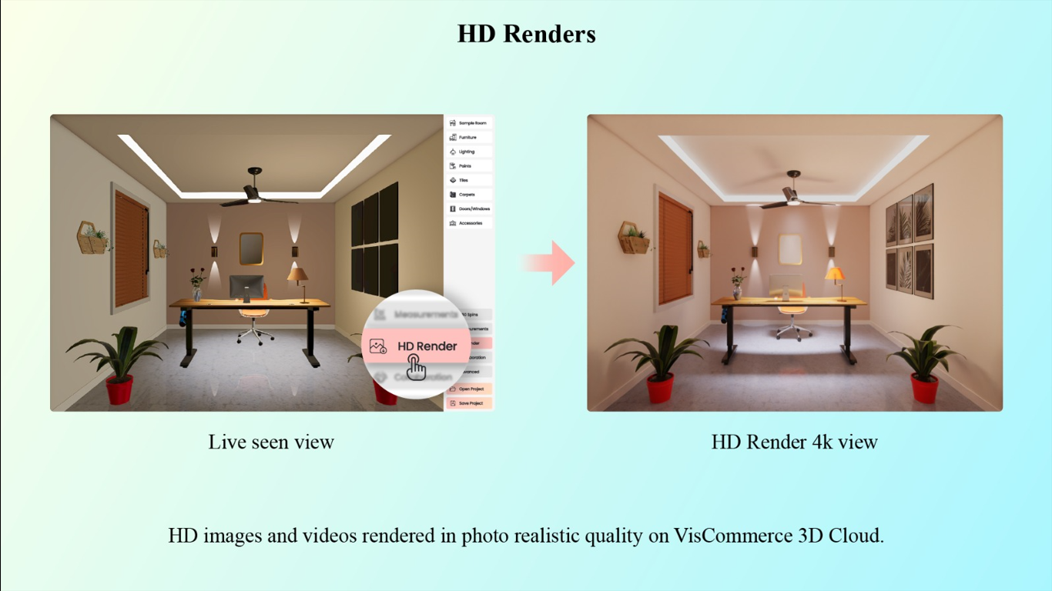

**Subject: Elevate Visuals with VisCommerce's 3D Room Planner: HD Renders and 4K Views**

Dear [Recipient's Name],

I trust this email finds you well. I am excited to delve into the exceptional capabilities of VisCommerce's 3D Room Planner, particularly its ability to generate stunning HD renders and 4K views that exhibit products in unparalleled photo-realistic quality.

This advanced feature not only enhances our product presentation but also elevates the way we engage customers within VisCommerce's 3D cloud environment.

In today's digital age, offering visuals that mirror reality is essential for captivating customers.

VisCommerce's 3D Room Planner harnesses the power of cutting-edge technology to provide an immersive experience that truly showcases our products.

**Here's how this feature transforms our presentation strategy:**

* **Live Scene Views:** The 3D Room Planner allows us to showcase live scene views, giving customers the ability to interact with products in real time. This dynamic experience enables users to explore items from different angles, promoting a more thorough understanding of our offerings.
* **HD Renders:** Our tool's HD render feature delivers exceptional detail and clarity. The high-definition renders depict products with accuracy and richness, allowing customers to scrutinize textures, finishes, and intricate details as if they were right in front of them.
* **4K Views:** The inclusion of 4K views takes the visual experience to another level. Our customers can enjoy an ultra-high-definition presentation that showcases every nuance of our products. This feature is particularly impactful for items that rely on intricate aesthetics and fine details.
* **Photo-Realistic Quality:** With VisCommerce's 3D Room Planner, we can now achieve photo-realistic quality in our visuals. This level of realism fosters a strong connection between customers and products, driving engagement and encouraging confident purchasing decisions.
* **Cloud-Based Convenience:** The 3D cloud environment ensures seamless access to these high-quality visuals from anywhere. Customers can engage with our products on their preferred devices, delivering a consistent and compelling experience across platforms.

The power of HD renders and 4K views in VisCommerce's 3D Room Planner lies in their ability to transform online interactions into immersive and dynamic experiences. This feature sets a new standard for visual product representation and demonstrates our commitment to providing customers with the most accurate and engaging shopping journey.

If you're interested in exploring the capabilities of HD renders and 4K views further, I'd be thrilled to provide additional insights or arrange a demonstration.

The VisCommerce 3D Room Planner is truly revolutionizing how we showcase our products, and I'm excited to see the impact it can have on our customer engagement.

Thank you for your time, and I look forward to your thoughts.

Best regards,